CN 5006 - Assignment 2

Margil Modi

2652423

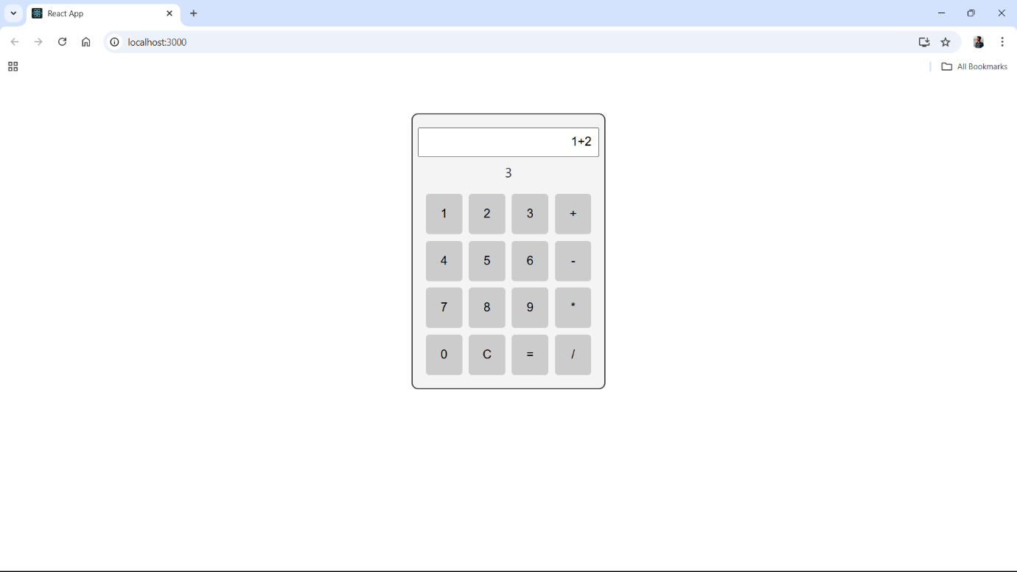

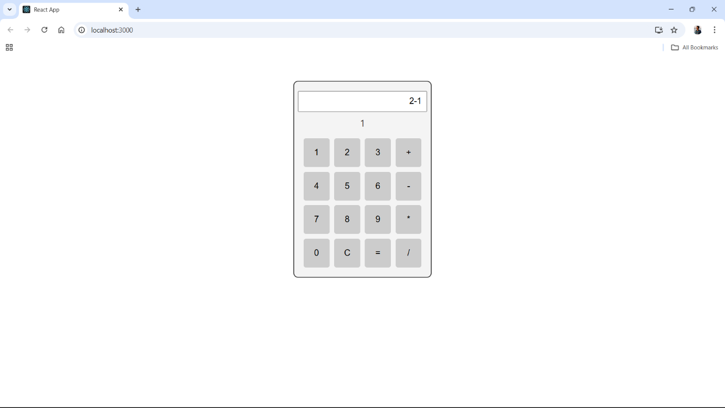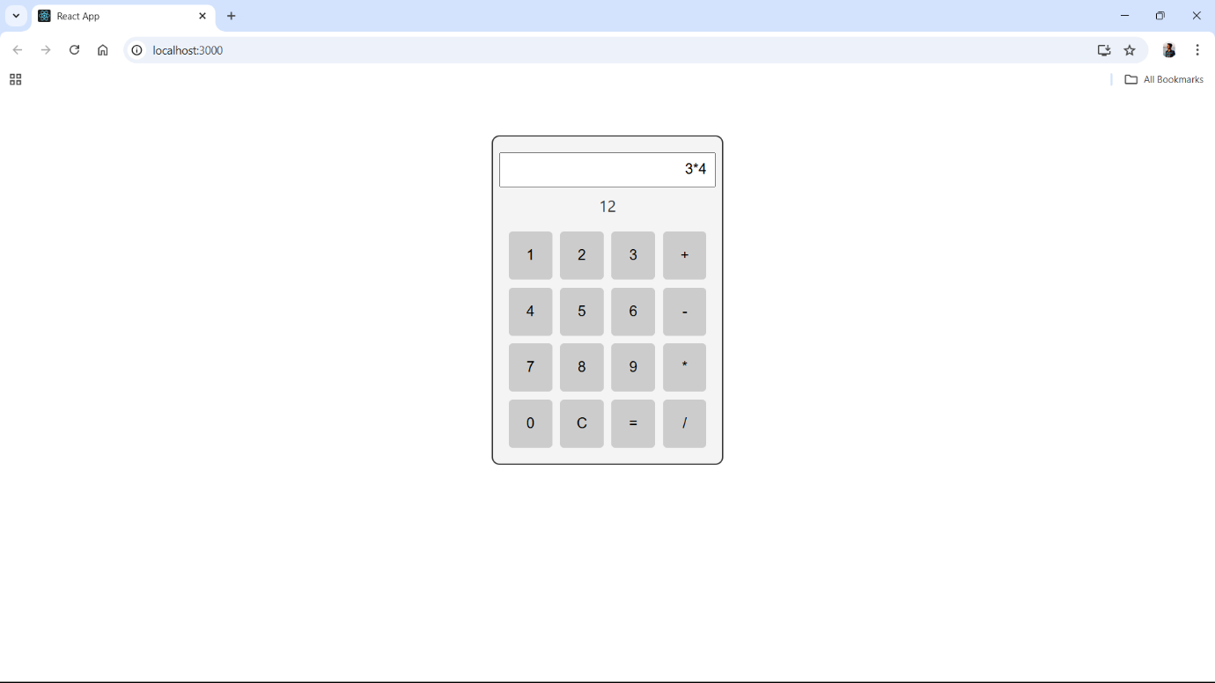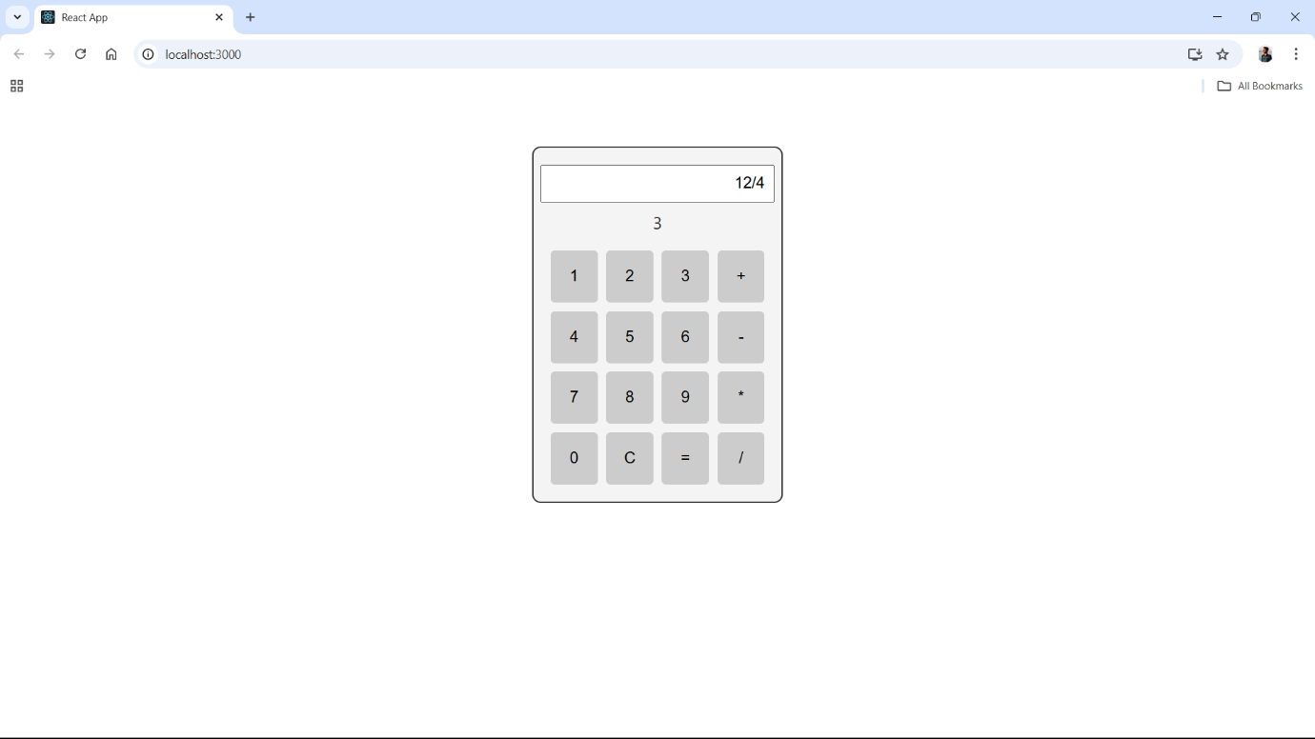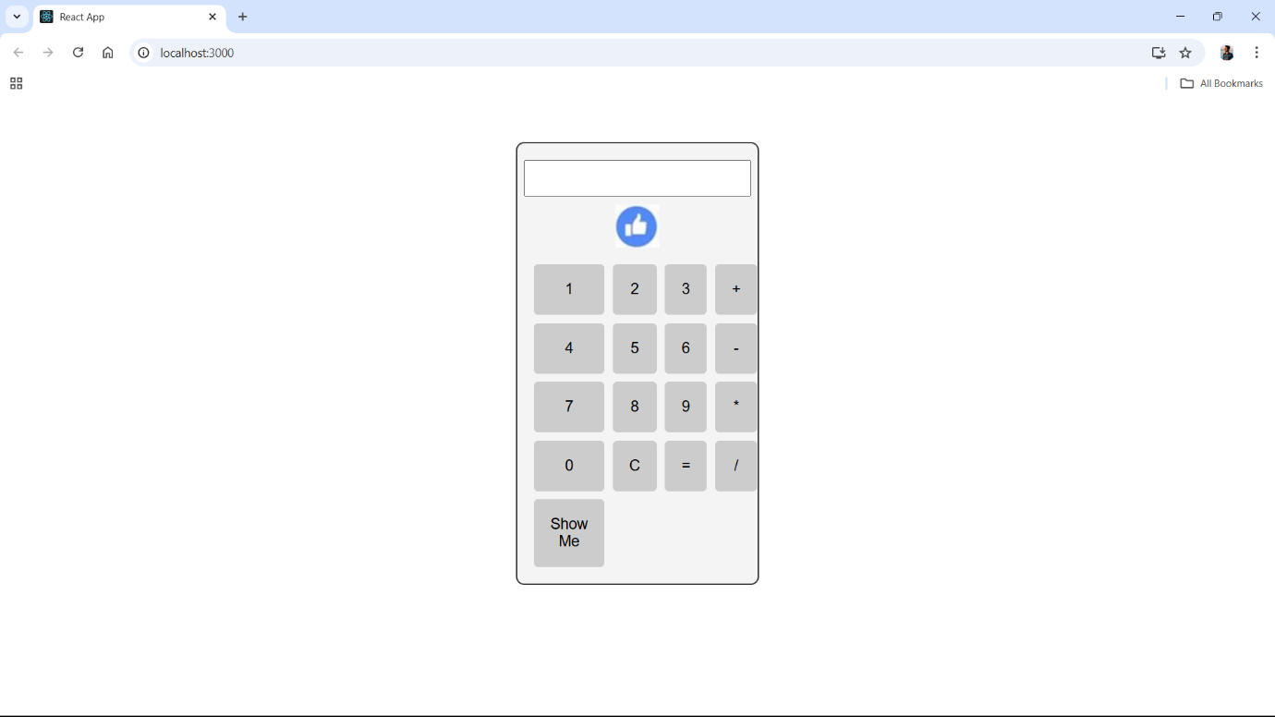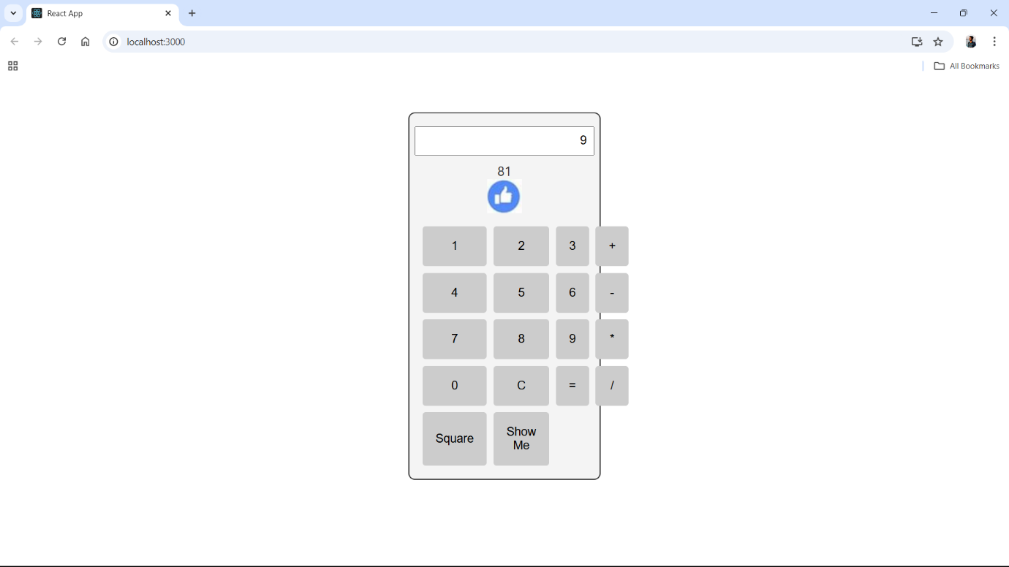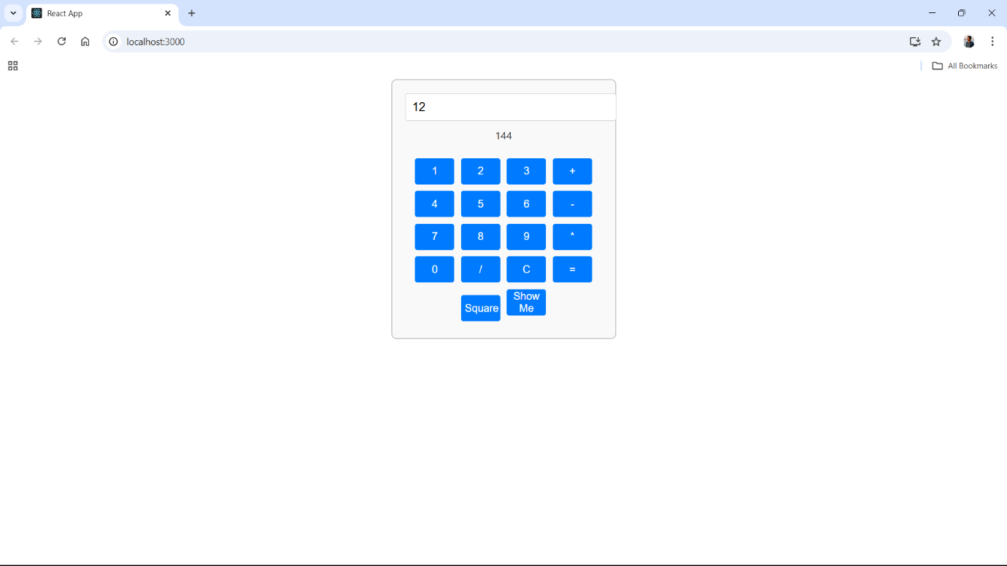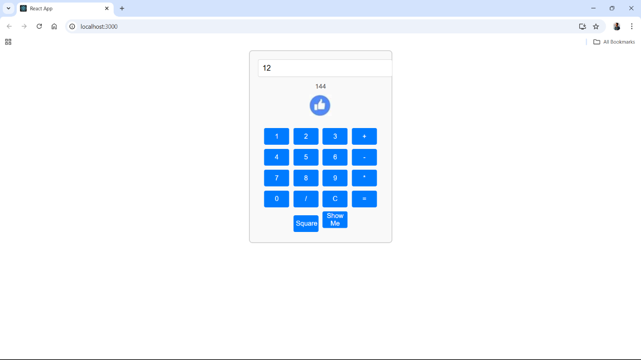

The Calculator component is the user interface, composed of an input text field at the top where the current calculation is shown and a grid of buttons for input. Users can perform basic arithmetic operations like addition, subtraction, multiplication, and division using the values from 0 to 9. It also includes keys for "C" to reset the current calculation, "=" to evaluate the expression, "Square" to calculate the square of the input number, and

"Show Me" for showing/hiding an image, although this functionality is not reflected in the code snippet herein presented.

The Calculator component relies on two state variables: showImage, which handles the picture that pops up with the "Show Me" button, and text1, which holds the current computation.

The ClickHandle function is really the core of the app; it processes button clicks to control operations that include processing operators and numeric inputs, the actual calculation, and clearing the input. The Button component renders each button on the calculator interface, also taking props for the label of the button and the ClickHandle method to ensure each button performs the action it is supposed to upon being clicked.

Setup of the application typically begins by creating a React environment with Create React App. ReactDOM.createRoot is used to create the root element of the application, in which the Calculator component can then be rendered. <React.StrictMode> is used throughout the application in order to detect potential problems that could arise in it during development.

To provide an aesthetically and intuitively pleasing user experience, styles are specified for both the calculator container and the entire body in the accompanying CSS file.

This project will skillfully combine these elements and styles to produce a useful and responsive calculator application in React, improving user experience while offering necessary mathematical functions.